Name: Khanh Vy Tran
StudentID: 120175245

ProTKD Tae Kwon Do

ProTKD Tae Kwon Do first opened their doors in 2001 at what now serves as their current head office in Thornhill, Ontario with the original business plan of offering Tae Kwon Do classes to children. Clients register their children using the Welcome to ProTKD Tae Kwon Do website.
Business is booming as parents recognize that their children require regular exercise routines. ProTKD Tae Kwon Do was rebranded and ProTKD Martial Arts and Fitness last year. ProTKD now offers classes across the Greater Toronto Area, utilizing space in both their owned facilities and community centers. Classes are now offered for adults as well as children.
ProTKD follows a ‘semester system’, scheduling classes in 16 week intervals. The summer semester is broken in to two half semesters, and fewer classes are scheduled for July/August.
Scheduling staff at ProTKD always work one semester ahead and class schedules are always posted two months prior to the start of the first class. Client needs are assessed through email and phone call surveys. Teaching staff are hired as required and schedules are created. Scheduling is tricky as ProTKD tries to schedule classes so that children under the age of ten are finished for the evening by 8:30 and that all siblings in a family are accommodated at the same location and same evening.
New families must first enroll with ProTKD as children cannot be added to a class unless the ProTKD is able to contact parents on an emergency basis. Once enrolled, parents are able to register for classes and fees are paid immediately. Early registration is encouraged by giving the prepared families discounts. If after two classes, a participant is not happy with the class, registration fees are refunded.
ProTKD owned facilities include a store where students are able to purchase healthy snacks and branded clothing. Purchases are added to the family account. Parents are sent an email monthly, invoicing the parents for any outstanding registration fees by student and store purchases by student. Parents are able to pay for their invoices via credit card, debit card or etransfer.
ProTKD staff are paid biweekly. Payroll and tax information are submitted to ABC Accounting Inc., Saturday evening at the end of the pay period. Payroll is deposited by ABC Accounting Inc. to staff bank accounts, the Thursday after the end of the pay period. Tax information is submitted to ABC Accounting Inc., monthly to ensure that taxes are paid on time. Bills are paid Monthly.
ProTKD Martial Arts and Fitness realize that their current website is outdated and doesn’t have the functionality required by the expanding business. ProTKD would like to build an integrated system that supports both clients and business requirements.

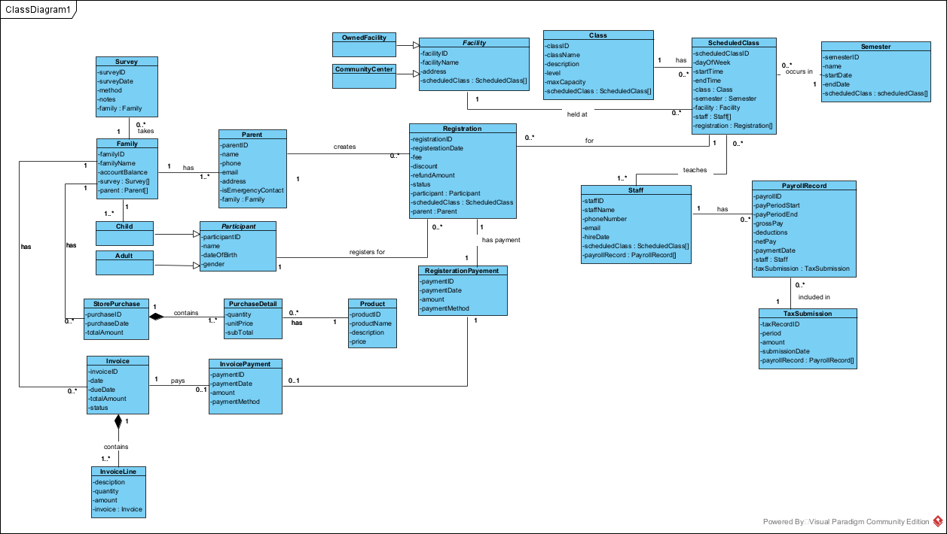
Question: Envisioning how the system would be developed, what Service Controllers would be needed for the application? What would these Service Controllers be used for?
- EnrollmentController: used to enroll new families, add parents/children/participants, and ensure emergency contact information is available before a child is registered for a class
- RegistrationController: used to register participants for classes, calculate fees and discounts, process refunds, and create registration payments
- SchedulingController: used to create semester schedules, assign classes to facilities, assign staff to classes, and check scheduling rules such as children under 10 finishing before 8:30 PM and siblings being scheduled at the same location and evening
- StorePurchaseController: used to record store purchases, add purchase details and products, and charge purchases to the family account
- InvoiceController: used to create monthly invoices for families, including registration fees and store purchases, and track invoice status
- PaymentController: used to record registration payments and invoice payments, including the payment method used
- PayrollController: used to create payroll records for staff and prepare payroll and tax information
- SurveyController: used to record client needs surveys completed by email or phone

